# A HOSPITAL MANAGEMENT WEBSITE USING FULL STACK FOR PROFESSIONAL TRAINING REPORT

**At**

SATHYABAMA INSTITUTE OF SCIENCE AND TECHNOLOGY

(DEEMED TO BE UNIVERSITY)

Submitted in partial fulfilment of the requirements for the award of Bachelor of Technology Degree in Information Technology

By

## DHARSINI M (41120054)

**DEPARTMENT OF INFORMATION TECHNOLOGY**

**SCHOOL OF COMPUTING**

**SATHYABAMA**

**INSTITUTE OF SCIENCE AND TECHNOLOGY**

**(DEEMED TO BE UNIVERSITY)**

**Category-1 University by UGC**

**Accredited with Grade “A++”by NAAC**

**12B Status by UGC |Approved by AICTE**

**JEPPIAAR NAGAR,RAJIV GANDHI SALAI,CHENNAI-600119**

**APRIL-2024**

|  | **SATHYABAMA**  **INSTITUTE OF SCIENCE AND TECHNOLOGY** (DEEMED TO BE UNIVERSITY)  **Accredited with Grade “A++” by NAAC**  JEPPIAAR NAGAR, RAJIV GANDHI SALAI  CHENNAI– 600119 |  |
| --- | --- | --- |



DEPARTMENT OF INFORMATION TECHNOLOGY

BONAFIDE CERTIFICATE

This is to certify that this Project Report is the bonafide work of **DHARSINI M (Reg.No:41120054)** who carried out the project entitled “**HOSPITAL MANAGEMENT SYSTEM WEBSITE USING FULL STACK DEVELOPMENT**” under my supervision from December 2023 to April 2024.

Internal Guide

Dr.Kamakshi, M.Tech.,Ph.D

Head of the Department

Dr.R.SUBHASHINI, M.E., Ph.D.

Submitted for Viva voce Examination held on

Internal Examiner External Examiner

**DECLARATION**

I,**DHARSINI M (41120054)** hereby declare that the PT-1 Report entitled **HOSPITAL MANAGEMENT WEBSITE USING FULL STACK** done by me under the guidance of **Dr.Kamakshi, M.Tech,Ph.D** (Internal)is submitted in partial fulfilment of the requirements for the award of Bachelor of Technology Degree in Information Technology.

## 

**DATE:**

**PLACE: CHENNAI SIGNATURE OF CANDIDATE**

**ACKNOWLEDGEMENT**

I am pleased to acknowledge my sincere thanks to **Board of Management** of **SATHYABAMA INSTITUTE OF SCIENCE AND TECHNOLOGY** for their kind encouragement in doing this project and for completing it successfully. I am grateful to them.

I convey my thanks to **Dr. T. Sasikala M.E., Ph.D.**, **Dean**, School of Computing **Dr. R. Subhashini, M.E., Ph.D.,** Head of the Department of Information Technology for providing me necessary support and details at the right time during the progressive reviews.

I would like to express my sincere and deep sense of gratitude to my Project Guide Dr.Kamakshi,M.E.,Ph.D for her valuable guidance, suggestions and constant encouragement paved way for the successful completion of my project work.

I wish to express my thanks to all Teaching and Non-teaching staff members of the **Department of Information Technology** who were helpful in many ways for the completion of the project.

TABLE OF CONTENTS

| CHAPTERNO. | TITLE | | | PageNo. |
| --- | --- | --- | --- | --- |
|  | ABSTRACT | | | v |
| 1 | INTRODUCTION | | | 2 |
|  | 1.1 | **PROBLEM STATEMENT** | | 4 |
|  | 1.2 | PROJECT STRUCTURE | | 5 |
| 2 | AIM AND SCOPE OF PROJECT | | |  |
|  | 2.1 | | AIM | 6 |
|  | 2.2 | | PROJECT OBJECTIVES | 7 |
|  | 2.3 | | SYSTEM SPECIFICATION | 8 |
|  | 2.4 | | SYSTEM ARCHITECTURE | 8 |
| 3 | METHODOLOGY | | |  |
|  | 3.1 | EXISTING SYSTEM | | 9 |
|  | 3.2 | PROPOSED SYSTEM | | 10 |
| 4 | PROGRAM | | |  |
|  | 4.1 | FOLDER | | 16 |
|  | 4.2 | FRONTEND MODULE | | 16 |
|  | 4.3 | BACKEND MODULE | |  |
| 5 | RESULTS AND DISCUSSION | | |  |
|  | 5.1 | OUTPUT | | 29 |
| 6 | CONCLUSION AND REFERENCES | | |  |
|  | 6.1 | CONCLUSION | | 30 |
|  | 6.2 | REFERENCES | | 31 |

ABSTRACT

Nowadays, the IT system has made many changes in the medical field. Managing a multi-speciality hospital is a challenging task in this fast-paced world of medicine. The fundamental changes in the way of solving organizational problems are the replacement of the traditional analytical approach with the systematic type assessment, according to a management type criterion, which examines the relationships and interaction between various organization components. Therefore, the need for a management type of organization is especially obvious in this field, especially in health services. Accordingly, the interactions between the hospital organization structure's systems and staff are analysed in an effort to enhance their management

Web application manages the storage and retrieval of information through a combination of server-side scripts and client-side (JavaScript and HTML) scripts to provide information to users. HMS is used to control the hospital services and either a mobile or a computer browser can access the HMS application. HMS application consists of ten main modules that include all details regarding doctors, patients, nurses, hospital administrative, etc. into one software. HMS allows the patients to register via a registration module (form), which gathers and stores all required patient’s data. Patients can view available appointments to book an appointment. Once the patient visits the hospital, the receptionist will issue a clinic number for him. when the patient’s turn came, the patient explains his condition to the consulting nurse, so that the nurse performs the pre-assessment examinations to diagnose the problem and then redirect him to the concerned doctor. Then, the concerned doctor will diagnose the patient, and then enter the prescription needed for the patient. If the patient needs further examination, then the doctor will redirect him to the nurse or lab assistant .

Therefore, the development team are designing this system that can help both patients and hospital workers using the motivation of this scenario, which was frequently performed in hospitals.

**CHAPTER – 1**

**INTRODUCTION**

Hospital management system (HMS) is a website to solve the complications coming from managing all the paperwork of every patient associated with the various departments of hospitalization with confidentiality. HMS provides the ability to manage all the paperwork in one place, reducing the work of staff in arranging and analyzing the paperwork of the patients. HMS does many works like:Maintain the medical records of the patient,Maintain the contact details of the patient,Keep track of the appointment dates, Save the insurance information for later reference, Tracking the bill payments. Web application manages the storage and retrieval of information through a combination of server-side scripts and client-side (JavaScript and HTML) scripts to provide information to users. HMS is used to control the hospital services and either a mobile or a computer browser can access the HMS application. HMS application consists of ten main modules that include all details regarding doctors, patients, nurses, hospital administrative, etc. into one software. HMS allows the patients to register via a registration module (form), which gathers and stores all required patient’s data. Patients can view available appointments to book an appointment. Once the patient visits the hospital, the receptionist will issue a clinic number for him. when the patient’s turn came, the patient explains his condition to the consulting nurse, so that the nurse performs the pre-assessment examinations to diagnose the problem and then redirect him to the concerned doctor. Then, the concerned doctor will diagnose the patient, and then enter the prescription needed for the patient. If the patient needs further examination, then the doctor will redirect him to the nurse or lab assistant .

User can search about the doctor whether they are available or not and the details of a patient. The hospital management system can be entered using a username and password. It is accessible either by an administrator or receptionist. Only they can add data into the database. The data can be retrieved easily. The interface is very user friendly. The data is well protected for personal use and fast data processing. Hospital Management System is designed for multispecialty hospitals, to cover awide range of hospital administration processes. Hospital Management System is a useful to improve the management of hospital in the area of clinical process analysis and activity-based costing.Hospital Management System enables you to develop your organization and improve effectiveness and quality of work. Improved Efficiency: By automating routine tasks and centralizing data management, our HMS website enhances operational efficiency, allowing healthcare providers to focus more on patient care.

Enhanced Patient Care: Access to accurate patient information and streamlined processes translates to improved patient care and satisfaction.

Cost Savings: Reduce administrative costs, minimize errors, and optimize resource utilization, leading to significant cost savings for your healthcare facility

.

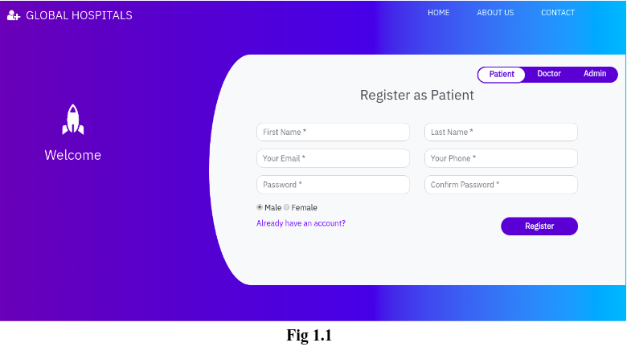

**Fig1 Hospital management system Website**

* 1. **PROBLEM STATEMENT:**

The aim of this study is to design and implement a database driven online virtual hospital management system with a particular reference to main hospital situated. today's dynamic healthcare landscape, effective management of hospital operations is critical for providing high-quality patient care while optimizing resource utilization and maintaining financial viability. However, many healthcare facilities still rely on fragmented and outdated systems, leading to inefficiencies, errors, and suboptimal patient experiences.

The challenge is to design and develop a robust hospital management system website that addresses these issues comprehensively. The system should seamlessly integrate administrative, clinical, and financial functions, providing a centralized platform for managing patient information, appointments, billing, inventory, and reporting. Key stakeholders including hospital administrators, healthcare providers, and patients should be able to access and interact with the system efficiently, contributing to improved workflow efficiency and patient outcomes.

Furthermore, the system should prioritize data security and compliance with healthcare regulations such as HIPAA (Health Insurance Portability and Accountability Act) to ensure the confidentiality and integrity of patient information. Scalability and flexibility are also essential considerations to accommodate the evolving needs of healthcare facilities and support future growth.

Ultimately, the goal is to develop a hospital management system website that empowers healthcare providers to deliver exceptional care, enhances operational efficiency, and fosters a positive patient experience, ultimately improving the overall quality and effectiveness of healthcare deliver

Design and develop a comprehensive hospital management system website to streamline administrative, clinical, and financial operations within a healthcare facility. The system should cater to the needs of hospital administrators, healthcare providers, and patients, providing efficient management of patient records, appointment scheduling, billing, inventory, and reporting. The goal is to enhance operational efficiency, improve patient care, and optimize resource utilization while ensuring data security and compliance with healthcare regulations. The system should be user-friendly, scalable, and customizable to meet the unique requirements of different healthcare settings.

**1.2 PROJECT STRUCTURE:**The project structure will look like

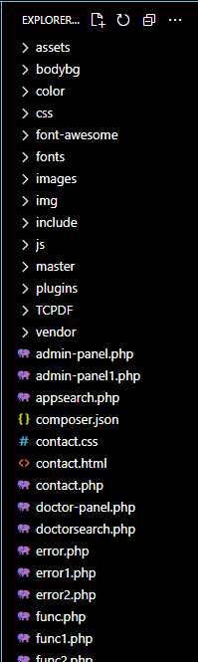

**Fig 1.3.1 Project Structure**

**CHAPTER – 2**

**AIM AND SCOPE OF PROJECT**

**2.1AIM:**

To create Hospital management system website using Fullstack

**2.2 PROJECT OBJECTIVES:**

* Hospital Management businesses are the need of the moment and almost all large and small companies are taking the online route to enhance their sales and to effectively compete with similar businesses online. To turn your online business into a successful one, it is mandatory to have an in-depth understanding of how Hospital Management business works, its features and characteristics and the objective of Hospital Management.
* There are various features of an Hospital Management business and you should be aware of all of them to set up business online. Let us understand what these features are all about.

### Technology-Enabled Hospital Management can be implemented through this website.

* Traditional commerce has been taking place since times immemorial but Hospital Management is the result of the integration of digital technology with commercial transactions and business processes. The technological foundations of Hospital management system are the internet, World Wide Web (WWW) and various other protocols.
* The number of customers for a traditional business is restricted in the city where it is located, whereas an Hospital Management business can reach globally. Hospital Management can be defined as a virtual marketplace that can be accessed online by customers through devices like mobile phones and computers.
* Thus, an Hospital Management marketplace motivates customers to buy products & services from any corner of the world where internet connection is available and then can pay the payment online. Due to the ubiquitous nature of the Hospital Management business, the working hours and geographical boundaries of catering enhance.
* Objective of Hospital Management for Hospital Management businesses have reached customers located all around the world. The Internet connects national boundaries. Hospital Management, without being limited by national and cultural boundaries, provides an opportunity to businessmen to cater to the customers seamlessly. This kind of marketplace has the capability to reach millions of worldwide customers.
* In Hospital Management businesses, buyers and sellers meet in cyber space rather than physical place. Hence, Hospital Management does not involve face to face contact.
* Commercial trading of products takes place through websites in Hospital Management. An Hospital Management website must be created based on the universally accepted methods and systems. Maintaining global standards aids the users of an Hospital Management website to efficiently use the website. Thus, universality of the website is one of the most essential features of an Hospital Management business.
* Interactivity serves as another important feature of an Hospital Management business. It refers to the two-way communication between the Hospital management and users of the Hospital Management website.
* **2.3 SYSTEM SPECIFICATION:**

**HARDWARE SPECIFICATION**

Processor : Processor Intel CORE i3 and above

RAM : 4 GB

Mouse : Digital

Keyboard : 105 Digital Keys

**SOFTWARE SPECIFICATION**

Operating System : Windows

Language : HTML, CSS, JAVASCRIPT, FULL STACK DEVELOPMENT.

GUI : Visual Studio (VS CODE).

**2.4 SYSTEM ARCHITECTURE:**

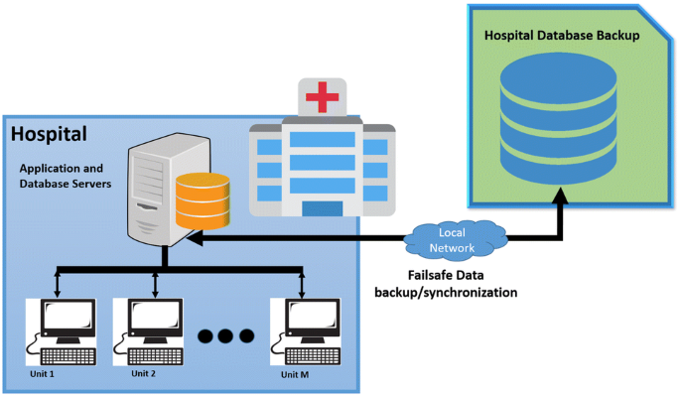

**Fig2.4.1 System Architecture**

**CHAPTER – 3**

**METHODOLOGY**

## 3.1 EXISTING SYSTEM

**​**Conducting an experimental analysis of hospital management websites involves assessing various aspects of their design, functionality, and user experience. Here is a step-by-step guide to help you conduct such an analysis:

**1. Define Objectives:**

- Clarify the purpose of the analysis: Identify the key aspects you want to evaluate, such as usability, accessibility, information accuracy, and overall user satisfaction.

**2. Select Evaluation Criteria:**

- Choose specific criteria for evaluation based on your objectives. This may include:

- Usability: Navigation, layout, clarity of information.

- Accessibility: Compliance with accessibility standards (WCAG), catering to users with disabilities.

- Performance: Page load times, responsiveness.

- Content: Accuracy, relevancy, completeness of medical information.

- Security: Data protection and privacy measures.

- User Interaction: Forms, appointment booking, feedback mechanisms.

- Design: Aesthetics, consistency, readability.

**3. Create Test Scenarios:**

- Develop realistic scenarios that users might encounter, such as finding a doctor, scheduling an appointment, or accessing medical records.

**4.Select Participants:**

- Recruit a diverse group of participants representing your target audience. Include individuals with varying levels of technical expertise.

**5. Execute the Evaluation:**

- Have participants perform tasks based on the test scenarios while observing and collecting data on their interactions.

- Use tools like screen recording, eye-tracking, or usability testing platforms to gather qualitative and quantitative data.

**6. Evaluate Accessibility:**

- Check for adherence to accessibility standards (e.g., WCAG) to ensure that the website is usable by individuals with disabilities.

**7. Performance Testing:**

- Assess the website's performance in terms of page load times and responsiveness, particularly on different devices and network speeds.

**8. Evaluate Security Measures:**

- Examine the website's security protocols, especially regarding patient data protection and privacy.

**9. Analyze User Feedback:**

- Collect feedback through surveys, interviews, or user comments to understand user perceptions and preferences.

**10. Report and Interpret Findings:**

- Summarize your findings, providing insights into strengths, weaknesses, and areas for improvement.

- Include actionable recommendations for enhancing the website's overall functionality and user experience.

**11. Iterative Testing and Improvement:**

- Conduct follow-up tests after implementing recommended changes to assess the impact and identify any new issues.

**12. Documentation:**

-Document your methodology, findings, and recommendations for future reference.

Remember, this analysis should be an ongoing process to keep the hospital management website aligned with user needs and technological advancements.

## PROPOSED SYSTEM

## Objectives:

## Clearly state the objectives of the proposed system. For example:

## Enhance overall hospital management efficiency.

## Improve patient care and experience.

## Streamline administrative processes.

## Ensure secure and compliant data handling..

**Key Features** **:**

Outline the essential features of the proposed hospital management system

* Patient Registration and Management: Streamlined processes for patient information entry, retrieval, and management.
* Appointment Scheduling: Efficient online scheduling for patients and doctors.
* Electronic Health Records (EHR): Secure storage and easy retrieval of patient health records.
* Billing and Invoicing: Automated billing processes for accurate financial transactions.
* Inventory Management: Monitoring and managing medical supplies and equipment.
* Doctor and Staff Management: Tracking schedules, performance, and workload.

Reporting and Analytics: Generate insights for informed decision-making.

**User Interface and Experience:**

Emphasize the importance of an intuitive and user-friendly interface to enhance the user experience.

Discuss the design principles that contribute to a positive user interaction.

**Integration and Compatibility:**

Explain how the proposed system will integrate with existing hospital infrastructure and software.

Highlight compatibility with various devices and browsers for accessibility.

**Security Measures:**

Discuss the security protocols implemented to safeguard patient data and comply with privacy regulations.

Include encryption, access controls, and regular security audits.

**Scalability:**

Address the system's scalability to accommodate the hospital's growth and evolving needs.

Describe how the system can handle an increasing volume of patients, staff, and data

**CHAPTER 4**

**PROGRAM**

**4.1 FOLDER**

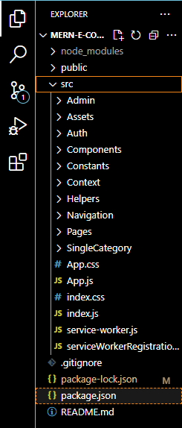 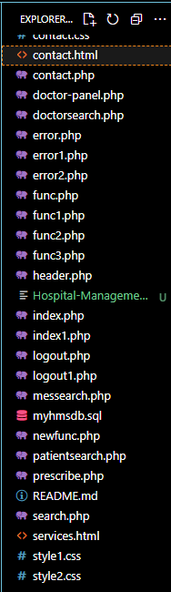

**Fig 4.1.1 Visual Code Side Bar**

4.2 FRONTEND MODULE

***.****<html>*

*<head>*

*<title>HMS</title>*

*<link rel="shortcut icon" type="image/x-icon" href="images/favicon.png" />*

*<link rel="stylesheet" type="text/css" href="style1.css">*

*<link href="https://fonts.googleapis.com/css?family=IBM+Plex+Sans&display=swap" rel="stylesheet">*

*<!-- <link rel="stylesheet" href="https://stackpath.bootstrapcdn.com/bootstrap/3.4.1/css/bootstrap.min.css" integrity="sha384-HSMxcRTRxnN+Bdg0JdbxYKrThecOKuH5zCYotlSAcp1+c8xmyTe9GYg1l9a69psu" crossorigin="anonymous"> -->*

*<link rel="stylesheet" href="https://stackpath.bootstrapcdn.com/bootstrap/4.3.1/css/bootstrap.min.css" integrity="sha384-ggOyR0iXCbMQv3Xipma34MD+dH/1fQ784/j6cY/iJTQUOhcWr7x9JvoRxT2MZw1T" crossorigin="anonymous">*

*<link rel="stylesheet" href="vendor/fontawesome/css/font-awesome.min.css">*

*<link href="//maxcdn.bootstrapcdn.com/bootstrap/4.1.1/css/bootstrap.min.css" rel="stylesheet" id="bootstrap-css">*

*<style >*

*.form-control {*

*border-radius: 0.75rem;*

*}*

*</style>*

*<script>*

*var check = function() {*

*if (document.getElementById('password').value ==*

*document.getElementById('cpassword').value) {*

*document.getElementById('message').style.color = '#5dd05d';*

*document.getElementById('message').innerHTML = 'Matched';*

*} else {*

*document.getElementById('message').style.color = '#f55252';*

*document.getElementById('message').innerHTML = 'Not Matching';*

*}*

*}*

*function alphaOnly(event) {*

*var key = event.keyCode;*

*return ((key >= 65 && key <= 90) || key == 8 || key == 32);*

*};*

*function checklen()*

*{*

*var pass1 = document.getElementById("password");*

*if(pass1.value.length<6){*

*alert("Password must be at least 6 characters long. Try again!");*

*return false;*

*}*

*}*

*</script>*

*</head>*

*<!------ Include the above in your HEAD tag ---------->*

*<body>*

*<nav class="navbar navbar-expand-lg navbar-dark fixed-top" id="mainNav" >*

*<div class="container">*

*<a class="navbar-brand js-scroll-trigger" href="#" style="margin-top: 10px;margin-left:-65px;font-family: 'IBM Plex Sans', sans-serif;"><h4><i class="fa fa-user-plus" aria-hidden="true"></i>&nbsp GLOBAL HOSPITALS</h4></a>*

*<button class="navbar-toggler" type="button" data-toggle="collapse" data-target="#navbarResponsive" aria-controls="navbarResponsive" aria-expanded="false" aria-label="Toggle navigation">*

*<span class="navbar-toggler-icon"></span>*

*</button>*

*<div class="collapse navbar-collapse" id="navbarResponsive">*

*<ul class="navbar-nav ml-auto">*

*<li class="nav-item" style="margin-right: 40px;">*

*<a class="nav-link js-scroll-trigger" href="index.php" style="color: white;font-family: 'IBM Plex Sans', sans-serif;"><h6>HOME</h6></a>*

*</li>*

*<li class="nav-item" style="margin-right: 40px;">*

*<a class="nav-link js-scroll-trigger" href="services.html" style="color: white;font-family: 'IBM Plex Sans', sans-serif;"><h6>ABOUT US</h6></a>*

*</li>*

*<li class="nav-item">*

*<a class="nav-link js-scroll-trigger" href="contact.html" style="color: white;font-family: 'IBM Plex Sans', sans-serif;"><h6>CONTACT</h6></a>*

*</li>*

*</ul>*

*</div>*

*</div>*

*</nav>*

*<div class="container register" style="font-family: 'IBM Plex Sans', sans-serif;">*

*<div class="row">*

*<div class="col-md-3 register-left" style="margin-top: 10%;right: 5%">*

*<img src="https://image.ibb.co/n7oTvU/logo_white.png" alt=""/>*

*<h3>Welcome</h3>*

*</div>*

*<div class="col-md-9 register-right" style="margin-top: 40px;left: 80px;">*

*<ul class="nav nav-tabs nav-justified" id="myTab" role="tablist" style="width: 40%;">*

*<li class="nav-item">*

*<a class="nav-link active" id="home-tab" data-toggle="tab" href="#home" role="tab" aria-controls="home" aria-selected="true">Patient</a>*

*</li>*

*<li class="nav-item">*

*<a class="nav-link" id="profile-tab" data-toggle="tab" href="#profile" role="tab" aria-controls="profile" aria-selected="false">Doctor</a>*

*</li>*

*<li class="nav-item">*

*<a class="nav-link" id="profile-tab" data-toggle="tab" href="#admin" role="tab" aria-controls="admin" aria-selected="false">Receptionist</a>*

*</li>*

*</ul>*

*<div class="tab-content" id="myTabContent">*

*<div class="tab-pane fade show active" id="home" role="tabpanel" aria-labelledby="home-tab">*

*<h3 class="register-heading">Register as Patient</h3>*

*<form method="post" action="func2.php">*

*<div class="row register-form">*

*<div class="col-md-6">*

*<div class="form-group">*

*<input type="text" class="form-control" placeholder="First Name *" name="fname" onkeydown="return alphaOnly(event);" required/>*

*</div>*

*<div class="form-group">*

*<input type="email" class="form-control" placeholder="Your Email *" name="email" />*

*</div>*

*<div class="form-group">*

*<input type="password" class="form-control" placeholder="Password *" id="password" name="password" onkeyup='check();' required/>*

*</div>*

*<div class="form-group">*

*<div class="maxl">*

*<label class="radio inline">*

*<input type="radio" name="gender" value="Male" checked>*

*<span> Male </span>*

*</label>*

*<label class="radio inline">*

*<input type="radio" name="gender" value="Female">*

*<span>Female </span>*

*</label>*

*</div>*

*<a href="index1.php">Already have an account?</a>*

*</div>*

*</div>*

*<div class="col-md-6">*

*<div class="form-group">*

*<input type="text" class="form-control" placeholder="Last Name *" name="lname" onkeydown="return alphaOnly(event);" required/>*

*</div>*

*<div class="form-group">*

*<input type="tel" minlength="10" maxlength="10" name="contact" class="form-control" placeholder="Your Phone *" />*

*</div>*

*<div class="form-group">*

*<input type="password" class="form-control" id="cpassword" placeholder="Confirm Password *" name="cpassword" onkeyup='check();' required/><span id='message'></span>*

*</div>*

*<input type="submit" class="btnRegister" name="patsub1" onclick="return checklen();" value="Register"/>*

*</div>*

*</div>*

*</form>*

*</div>*

*<div class="tab-pane fade show" id="profile" role="tabpanel" aria-labelledby="profile-tab">*

*<h3 class="register-heading">Login as Doctor</h3>*

*<form method="post" action="func1.php">*

*<div class="row register-form">*

*<div class="col-md-6">*

*<div class="form-group">*

*<input type="text" class="form-control" placeholder="User Name *" name="username3" onkeydown="return alphaOnly(event);" required/>*

*</div>*

*</div>*

*<div class="col-md-6">*

*<div class="form-group">*

*<input type="password" class="form-control" placeholder="Password *" name="password3" required/>*

*</div>*

*<input type="submit" class="btnRegister" name="docsub1" value="Login"/>*

*</div>*

*</div>*

*</form>*

*</div>*

*<div class="tab-pane fade show" id="admin" role="tabpanel" aria-labelledby="profile-tab">*

*<h3 class="register-heading">Login as Admin</h3>*

*<form method="post" action="func3.php">*

*<div class="row register-form">*

*<div class="col-md-6">*

*<div class="form-group">*

*<input type="text" class="form-control" placeholder="User Name *" name="username1" onkeydown="return alphaOnly(event);" required/>*

*</div>*

*</div>*

*<div class="col-md-6">*

*<div class="form-group">*

*<input type="password" class="form-control" placeholder="Password *" name="password2" required/>*

*</div>*

*<input type="submit" class="btnRegister" name="adsub" value="Login"/>*

*</div>*

*</div>*

*</form>*

*</div>*

*</div>*

*</div>*

*</div>*

*</div>*

*</body>*

*<script src="https://code.jquery.com/jquery-3.3.1.slim.min.js" integrity="sha384-q8i/X+965DzO0rT7abK41JStQIAqVgRVzpbzo5smXKp4YfRvH+8abtTE1Pi6jizo" crossorigin="anonymous"></script>*

*<script src="https://cdnjs.cloudflare.com/ajax/libs/popper.js/1.14.7/umd/popper.min.js" integrity="sha384-UO2eT0CpHqdSJQ6hJty5KVphtPhzWj9WO1clHTMGa3JDZwrnQq4sF86dIHNDz0W1" crossorigin="anonymous"></script>*

*<script src="https://stackpath.bootstrapcdn.com/bootstrap/4.3.1/js/bootstrap.min.js" integrity="sha384-JjSmVgyd0p3pXB1rRibZUAYoIIy6OrQ6VrjIEaFf/nJGzIxFDsf4x0xIM+B07jRM" crossorigin="anonymous"></script>*

*<script src="https://stackpath.bootstrapcdn.com/bootstrap/3.4.1/js/bootstrap.min.js" integrity="sha384-aJ21OjlMXNL5UyIl/XNwTMqvzeRMZH2w8c5cRVpzpU8Y5bApTppSuUkhZXN0VxHd" crossorigin="anonymous"></script>*

*</html>*

**4.3 BACKEND MODULE**

*-- phpMyAdmin SQL Dump*

*-- version 4.8.0*

*-- https://www.phpmyadmin.net/*

*--*

*-- Host: localhost*

*-- Generation Time: Mar 16, 2020 at 02:34 AM*

*-- Server version: 10.1.31-MariaDB*

*-- PHP Version: 7.2.4*

*SET SQL_MODE = "NO_AUTO_VALUE_ON_ZERO";*

*SET AUTOCOMMIT = 0;*

*START TRANSACTION;*

*SET time_zone = "+00:00";*

*/*!40101 SET @OLD_CHARACTER_SET_CLIENT=@@CHARACTER_SET_CLIENT */;*

*/*!40101 SET @OLD_CHARACTER_SET_RESULTS=@@CHARACTER_SET_RESULTS */;*

*/*!40101 SET @OLD_COLLATION_CONNECTION=@@COLLATION_CONNECTION */;*

*/*!40101 SET NAMES utf8mb4 */;*

*--*

*-- Database: `myhmsdb`*

*--*

*-- --------------------------------------------------------*

*--*

*-- Table structure for table `admintb`*

*--*

*CREATE TABLE `admintb` (*

*`username` varchar(50) NOT NULL,*

*`password` varchar(30) NOT NULL*

*) ENGINE=InnoDB DEFAULT CHARSET=latin1;*

*--*

*-- Dumping data for table `admintb`*

*--*

*INSERT INTO `admintb` (`username`, `password`) VALUES*

*('admin', 'admin123');*

*-- --------------------------------------------------------*

*--*

*-- Table structure for table `appointmenttb`*

*--*

*CREATE TABLE `appointmenttb` (*

*`pid` int(11) NOT NULL,*

*`ID` int(11) NOT NULL,*

*`fname` varchar(20) NOT NULL,*

*`lname` varchar(20) NOT NULL,*

*`gender` varchar(10) NOT NULL,*

*`email` varchar(30) NOT NULL,*

*`contact` varchar(10) NOT NULL,*

*`doctor` varchar(30) NOT NULL,*

*`docFees` int(5) NOT NULL,*

*`appdate` date NOT NULL,*

*`apptime` time NOT NULL,*

*`userStatus` int(5) NOT NULL,*

*`doctorStatus` int(5) NOT NULL*

*) ENGINE=InnoDB DEFAULT CHARSET=latin1;*

*--*

*-- Dumping data for table `appointmenttb`*

*--*

*INSERT INTO `appointmenttb` (`pid`, `ID`, `fname`, `lname`, `gender`, `email`, `contact`, `doctor`, `docFees`, `appdate`, `apptime`, `userStatus`, `doctorStatus`) VALUES*

*(4, 1, 'Kishan', 'Lal', 'Male', 'kishansmart0@gmail.com', '8838489464', 'Ganesh', 550, '2020-02-14', '10:00:00', 1, 0),*

*(4, 2, 'Kishan', 'Lal', 'Male', 'kishansmart0@gmail.com', '8838489464', 'Dinesh', 700, '2020-02-28', '10:00:00', 0, 1),*

*(4, 3, 'Kishan', 'Lal', 'Male', 'kishansmart0@gmail.com', '8838489464', 'Amit', 1000, '2020-02-19', '03:00:00', 0, 1),*

*(11, 4, 'Shraddha', 'Kapoor', 'Female', 'shraddha@gmail.com', '9768946252', 'ashok', 500, '2020-02-29', '20:00:00', 1, 1),*

*(4, 5, 'Kishan', 'Lal', 'Male', 'kishansmart0@gmail.com', '8838489464', 'Dinesh', 700, '2020-02-28', '12:00:00', 1, 1),*

*(4, 6, 'Kishan', 'Lal', 'Male', 'kishansmart0@gmail.com', '8838489464', 'Ganesh', 550, '2020-02-26', '15:00:00', 0, 1),*

*(2, 8, 'Alia', 'Bhatt', 'Female', 'alia@gmail.com', '8976897689', 'Ganesh', 550, '2020-03-21', '10:00:00', 1, 1),*

*(5, 9, 'Gautam', 'Shankararam', 'Male', 'gautam@gmail.com', '9070897653', 'Ganesh', 550, '2020-03-19', '20:00:00', 1, 0),*

*(4, 10, 'Kishan', 'Lal', 'Male', 'kishansmart0@gmail.com', '8838489464', 'Ganesh', 550, '0000-00-00', '14:00:00', 1, 0),*

*(4, 11, 'Kishan', 'Lal', 'Male', 'kishansmart0@gmail.com', '8838489464', 'Dinesh', 700, '2020-03-27', '15:00:00', 1, 1),*

*(9, 12, 'William', 'Blake', 'Male', 'william@gmail.com', '8683619153', 'Kumar', 800, '2020-03-26', '12:00:00', 1, 1),*

*(9, 13, 'William', 'Blake', 'Male', 'william@gmail.com', '8683619153', 'Tiwary', 450, '2020-03-26', '14:00:00', 1, 1);*

*-- --------------------------------------------------------*

*--*

*-- Table structure for table `contact`*

*--*

*CREATE TABLE `contact` (*

*`name` varchar(30) NOT NULL,*

*`email` text NOT NULL,*

*`contact` varchar(10) NOT NULL,*

*`message` varchar(200) NOT NULL*

*) ENGINE=InnoDB DEFAULT CHARSET=latin1;*

*--*

*-- Dumping data for table `contact`*

*--*

*INSERT INTO `contact` (`name`, `email`, `contact`, `message`) VALUES*

*('Anu', 'anu@gmail.com', '7896677554', 'Hey Admin'),*

*(' Viki', 'viki@gmail.com', '9899778865', 'Good Job, Pal'),*

*('Ananya', 'ananya@gmail.com', '9997888879', 'How can I reach you?'),*

*('Aakash', 'aakash@gmail.com', '8788979967', 'Love your site'),*

*('Mani', 'mani@gmail.com', '8977768978', 'Want some coffee?'),*

*('Karthick', 'karthi@gmail.com', '9898989898', 'Good service'),*

*('Abbis', 'abbis@gmail.com', '8979776868', 'Love your service'),*

*('Asiq', 'asiq@gmail.com', '9087897564', 'Love your service. Thank you!'),*

*('Jane', 'jane@gmail.com', '7869869757', 'I love your service!');*

*-- --------------------------------------------------------*

*--*

*-- Table structure for table `doctb`*

*--*

*CREATE TABLE `doctb` (*

*`username` varchar(50) NOT NULL,*

*`password` varchar(50) NOT NULL,*

*`email` varchar(50) NOT NULL,*

*`spec` varchar(50) NOT NULL,*

*`docFees` int(10) NOT NULL*

*) ENGINE=InnoDB DEFAULT CHARSET=latin1;*

*--*

*-- Dumping data for table `doctb`*

*--*

*INSERT INTO `doctb` (`username`, `password`, `email`, `spec`, `docFees`) VALUES*

*('ashok', 'ashok123', 'ashok@gmail.com', 'General', 500),*

*('arun', 'arun123', 'arun@gmail.com', 'Cardiologist', 600),*

*('Dinesh', 'dinesh123', 'dinesh@gmail.com', 'General', 700),*

*('Ganesh', 'ganesh123', 'ganesh@gmail.com', 'Pediatrician', 550),*

*('Kumar', 'kumar123', 'kumar@gmail.com', 'Pediatrician', 800),*

*('Amit', 'amit123', 'amit@gmail.com', 'Cardiologist', 1000),*

*('Abbis', 'abbis123', 'abbis@gmail.com', 'Neurologist', 1500),*

*('Tiwary', 'tiwary123', 'tiwary@gmail.com', 'Pediatrician', 450);*

*-- --------------------------------------------------------*

*--*

*-- Table structure for table `patreg`*

*--*

*CREATE TABLE `patreg` (*

*`pid` int(11) NOT NULL,*

*`fname` varchar(20) NOT NULL,*

*`lname` varchar(20) NOT NULL,*

*`gender` varchar(10) NOT NULL,*

*`email` varchar(30) NOT NULL,*

*`contact` varchar(10) NOT NULL,*

*`password` varchar(30) NOT NULL,*

*`cpassword` varchar(30) NOT NULL*

*) ENGINE=InnoDB DEFAULT CHARSET=latin1;*

*--*

*-- Dumping data for table `patreg`*

*--*

*INSERT INTO `patreg` (`pid`, `fname`, `lname`, `gender`, `email`, `contact`, `password`, `cpassword`) VALUES*

*(1, 'Ram', 'Kumar', 'Male', 'ram@gmail.com', '9876543210', 'ram123', 'ram123'),*

*(2, 'Alia', 'Bhatt', 'Female', 'alia@gmail.com', '8976897689', 'alia123', 'alia123'),*

*(3, 'Shahrukh', 'khan', 'Male', 'shahrukh@gmail.com', '8976898463', 'shahrukh123', 'shahrukh123'),*

*(4, 'Kishan', 'Lal', 'Male', 'kishansmart0@gmail.com', '8838489464', 'kishan123', 'kishan123'),*

*(5, 'Gautam', 'Shankararam', 'Male', 'gautam@gmail.com', '9070897653', 'gautam123', 'gautam123'),*

*(6, 'Sushant', 'Singh', 'Male', 'sushant@gmail.com', '9059986865', 'sushant123', 'sushant123'),*

*(7, 'Nancy', 'Deborah', 'Female', 'nancy@gmail.com', '9128972454', 'nancy123', 'nancy123'),*

*(8, 'Kenny', 'Sebastian', 'Male', 'kenny@gmail.com', '9809879868', 'kenny123', 'kenny123'),*

*(9, 'William', 'Blake', 'Male', 'william@gmail.com', '8683619153', 'william123', 'william123'),*

*(10, 'Peter', 'Norvig', 'Male', 'peter@gmail.com', '9609362815', 'peter123', 'peter123'),*

*(11, 'Shraddha', 'Kapoor', 'Female', 'shraddha@gmail.com', '9768946252', 'shraddha123', 'shraddha123');*

*-- --------------------------------------------------------*

*--*

*-- Table structure for table `prestb`*

*--*

*CREATE TABLE `prestb` (*

*`doctor` varchar(50) NOT NULL,*

*`pid` int(11) NOT NULL,*

*`ID` int(11) NOT NULL,*

*`fname` varchar(50) NOT NULL,*

*`lname` varchar(50) NOT NULL,*

*`appdate` date NOT NULL,*

*`apptime` time NOT NULL,*

*`disease` varchar(250) NOT NULL,*

*`allergy` varchar(250) NOT NULL,*

*`prescription` varchar(1000) NOT NULL*

*) ENGINE=InnoDB DEFAULT CHARSET=latin1;*

*--*

*-- Dumping data for table `prestb`*

*--*

*INSERT INTO `prestb` (`doctor`, `pid`, `ID`, `fname`, `lname`, `appdate`, `apptime`, `disease`, `allergy`, `prescription`) VALUES*

*('Dinesh', 4, 11, 'Kishan', 'Lal', '2020-03-27', '15:00:00', 'Cough', 'Nothing', 'Just take a teaspoon of Benadryl every night'),*

*('Ganesh', 2, 8, 'Alia', 'Bhatt', '2020-03-21', '10:00:00', 'Severe Fever', 'Nothing', 'Take bed rest'),*

*('Kumar', 9, 12, 'William', 'Blake', '2020-03-26', '12:00:00', 'Sever fever', 'nothing', 'Paracetamol -> 1 every morning and night'),*

*('Tiwary', 9, 13, 'William', 'Blake', '2020-03-26', '14:00:00', 'Cough', 'Skin dryness', 'Intake fruits with more water content');*

*--*

*-- Indexes for dumped tables*

*--*

*--*

*-- Indexes for table `appointmenttb`*

*--*

*ALTER TABLE `appointmenttb`*

*ADD PRIMARY KEY (`ID`);*

*--*

*-- Indexes for table `patreg`*

*--*

*ALTER TABLE `patreg`*

*ADD PRIMARY KEY (`pid`);*

*--*

*-- AUTO_INCREMENT for dumped tables*

*--*

*--*

*-- AUTO_INCREMENT for table `appointmenttb`*

*--*

*ALTER TABLE `appointmenttb`*

*MODIFY `ID` int(11) NOT NULL AUTO_INCREMENT, AUTO_INCREMENT=14;*

*--*

*-- AUTO_INCREMENT for table `patreg`*

*--*

*ALTER TABLE `patreg`*

*MODIFY `pid` int(11) NOT NULL AUTO_INCREMENT, AUTO_INCREMENT=12;*

*COMMIT;*

*/*!40101 SET CHARACTER_SET_CLIENT=@OLD_CHARACTER_SET_CLIENT */;*

*/*!40101 SET CHARACTER_SET_RESULTS=@OLD_CHARACTER_SET_RESULTS */;*

*/*!40101 SET COLLATION_CONNECTION=@OLD_COLLATION_CONNECTION */;*

**CHAPTER 5**

**OUTPUT**

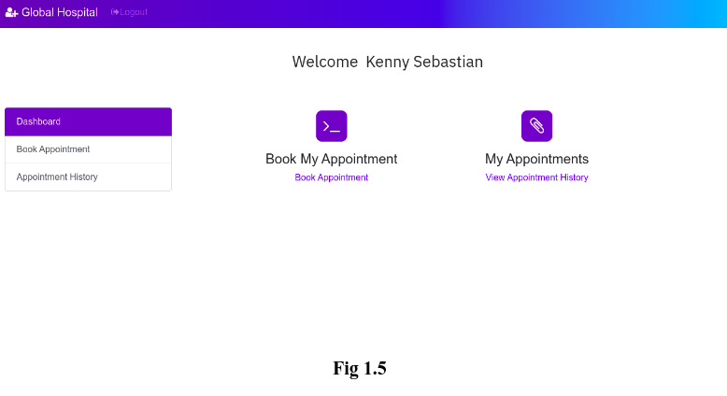

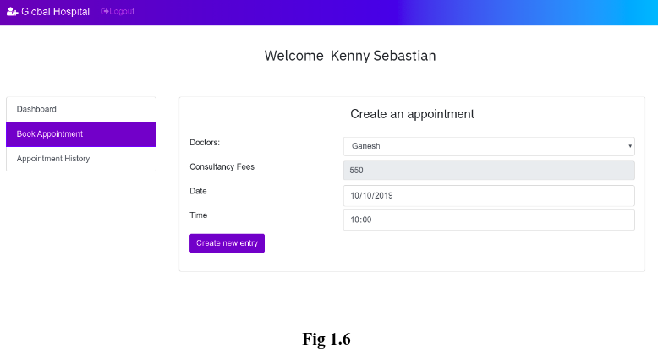

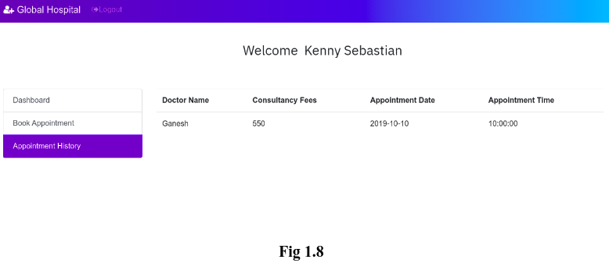

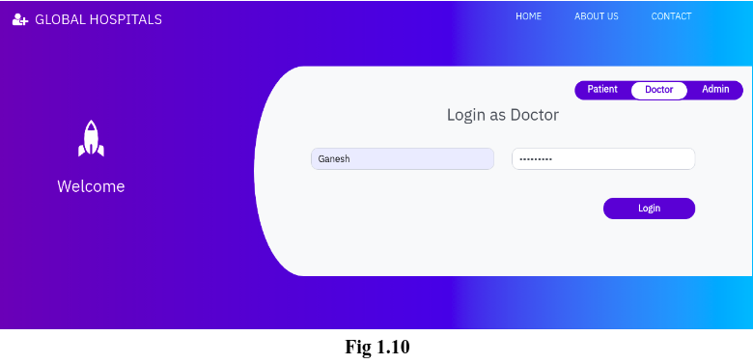

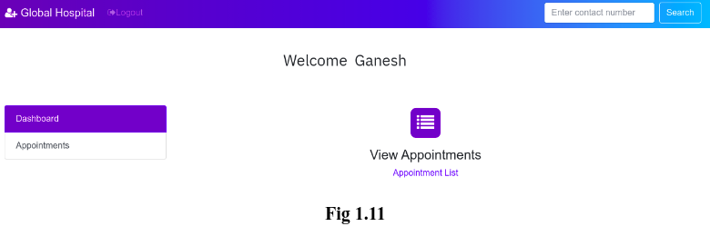

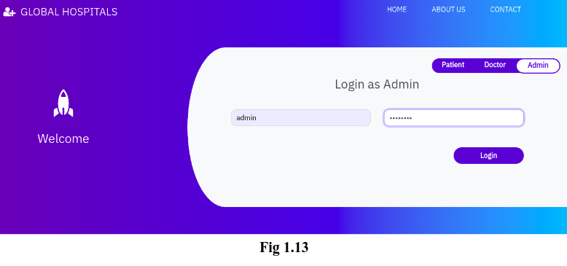

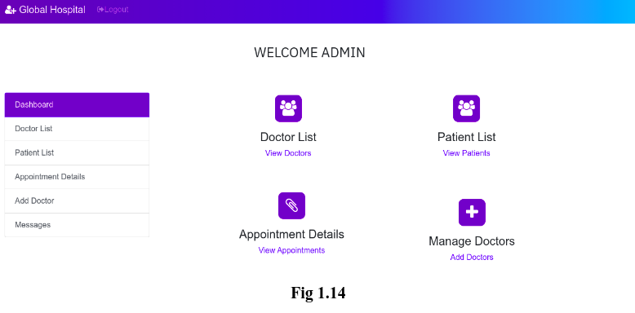

**CHAPTER 6**

**CONCLUSION**

In conclusion, the development and implementation of a full-stack hospital management website mark a significant advancement in enhancing the efficiency, accessibility, and overall quality of healthcare services. The integration of both front-end and back-end technologies allows for a seamless and user-friendly experience for both healthcare professionals and patients.

Through the utilization of modern web technologies, such as responsive design and intuitive user interfaces, the hospital management website ensures accessibility across various devices, making information readily available to users at any time and from anywhere. This accessibility fosters improved communication, coordination, and collaboration among healthcare providers, leading to enhanced patient care.

The robust back-end infrastructure plays a crucial role in managing and processing vast amounts of data generated in a healthcare setting. This includes patient records, appointment scheduling, inventory management, and other critical functionalities. The full-stack approach facilitates the integration of diverse systems, streamlining operations and reducing the likelihood of errors.

Security is a paramount concern in healthcare, and the full-stack development of the hospital management website ensures the implementation of robust security measures. This safeguards sensitive patient information, maintains the integrity of data, and complies with regulatory standards, instilling trust among both healthcare professionals and patients.

Moreover, the continuous evolution of healthcare technologies demands a scalable and adaptable solution. The full-stack architecture allows for flexibility in incorporating new features, updates, and integrations to keep pace with the dynamic nature of the healthcare industry. This adaptability ensures that the hospital management website remains relevant and effective in addressing the evolving needs of the healthcare ecosystem.

In conclusion, the development of a hospital management website using a full-stack approach not only streamlines daily operations but also contributes to the overall improvement of healthcare delivery. By combining cutting-edge technologies, user-centric design, and a robust back-end infrastructure, such a website becomes an invaluable tool in promoting efficiency, accuracy, and accessibility in the healthcare domain.

**REFERENCE**

* "Full Stack Development with JHipster" by Deepu K Sasidharan and Sendil Kumar
* "MEAN Web Development" by Amos Q. Haviv
* W3Schools (https://www.w3schools.com): A resource for learning web technologies with tutorials and references.
* Stack Overflow (https://stackoverflow.com): A community-driven platform where developers discuss and share their knowledge. You can find discussions on full-stack development and specific technologies.
* "Hospital Management System - A Case Study" by Pradeep Reddy Mamidi (International Journal of Computer Science and Information Technologies)